Thorpe Hamlet
Parish Magazine
Serving the people of Thorpe Hamlet

April/May 2017 St Matthews Church Thorpe Hamlet £1
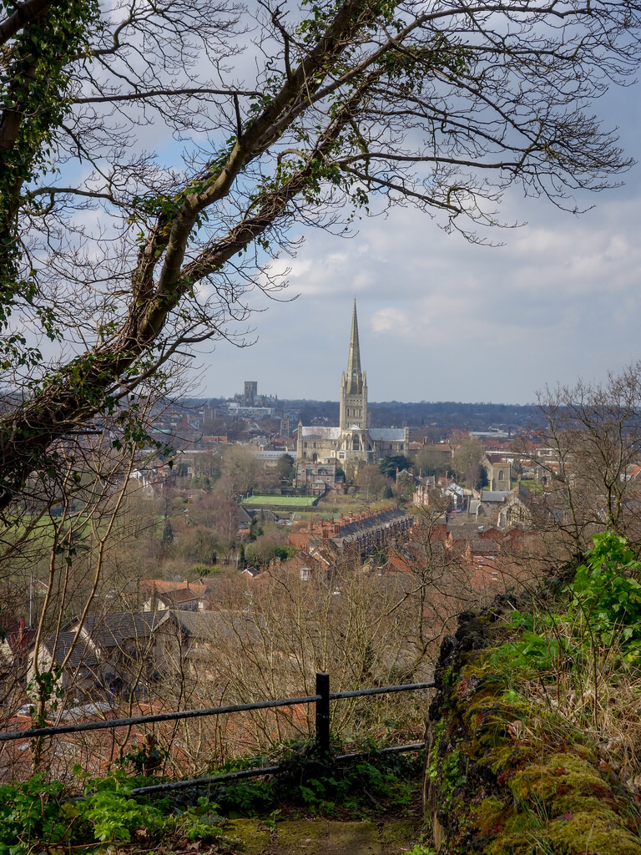

Letter from the Vicar,

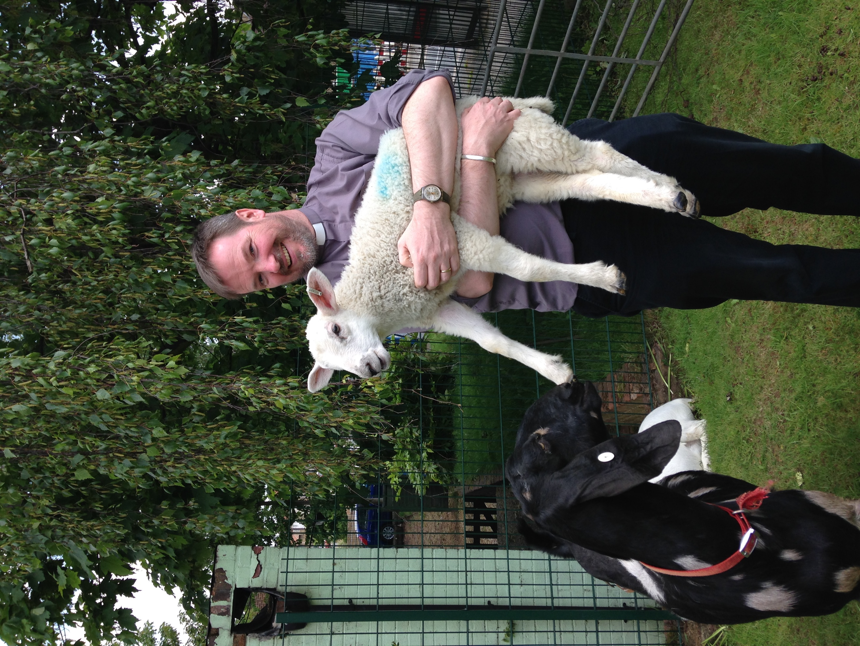
It has been a joy to see the Roof appeal being such a success. We need to raise £100,000 aprox to replace our roof with one which is insulated and keeps the water out! The first target was £10’000 by Easter and we had achieved that before the end of March which is a great start.

It seems odd to be raising money at the same time as Comic relief is trying to raise money for essential causes in this country and in Africa. After all what does St Matthew’s do for the wider Community?

This really is like the What do the Romans do for us? Question from the life of Brian. We host Choirs, provide meals through social Clubs and through FISH (Food in School Holidays.) we run toddler groups, and youth Clubs, host classes for adults, support refugees, offer Worship opportunities and help celebrate key moments in our lives with baptisms, weddings and Funerals. We have recently hosted history groups, residents associations and Sea Cadets, as well as making our space available to our Schools for Concerts.

St Matthews is a resource for our whole community, for those celebrating faith, exploring it, or simply looking for a space and community who will care about the things you care about. I hope your able to support St Matthews, more importantly I hope St Matthews can be a place that supports you.

Rev Patrick Jordan

Helen’s Suger free Lent

Thank to many of you who sponsored me to give up sugar for Lent to raise money for the roof appeal at the time of writing I have raised £300 which much more than I expected.
I suppose it tells us something about expectations. We all have them whether starting something new or when we meet people. My expectations were less and perhaps with our mission action plan for the Diocese we do need to imagine more. Imagine that the people we meet have many gifts, skills and talents to offer us and we to them. Imagine that new situation can teach us more about God not less. Imagine that church has more to offer us as community.
Yes we are all fund raising for the roof appeal and so far it has given us much more in return more community, more fun, more opportunities so here's to more not less. Helen

Wild about The Rosary
Saturday 10 June 2017
10am to 4pm
Meeting point: The Chapel, Rosary Cemetery, Rosary Lane, Norwich, Norfolk, NR1 4BZ

Join Norfolk Wildlife Trust and The Friends of the Rosary as they discover the wildlife associated with The Rosary Cemetery through a series of guided walks and displays. There will be the chance to meet the experts and go on lots of different walks from butterflies to bees, wildflowers to trees. Also for the young at heart why not join us on a minibeast safari at 11am and 1pm? There will also be the opportunity to have a go at a wildlife treasure trail, who knows what you might discover?

To find out more visit the What’s On section at www.norfolkwildlifetrust.org.uk

ST MATTHEW’S CHURCH
& COMMUNITY CENTRE
TELEGRAPH LANE WEST,
THORPE HAMLET

– EASTER MONDAY
17th April
10am 4.30pm

St Matthew’s Roof Appeal Launch
12 noon
ROCKET LAUNCH

❖ Buy a tile & put your name on it
❖ Thorpe Hamlet History Trails
❖ Guided walks
❖Stalls & Displays in Church
❖ REFRESHMENTS

‘Meet friends old & new’

A reflective Easter article by Rev’d Keith Rengert guest writer
I was asked this last week which was the most important, Christmas or Easter and which did I prefer?
The first question is quite difficult to answer as it’s a bit of a ‘chicken & the egg’ question. Of course, Jesus could not have died and risen if he were not born in the first place. The answer to the first question is, I suppose, that they are both important and both crucial to the churches understanding of our Christian faith, as recited weekly in one of our creedal (faith) statements,
‘I believe in Jesus Christ, his only Son, our Lord,
who was conceived by the Holy Spirit,
born of the Virgin Mary, suffered under Pontius Pilate, was crucified, died, and was buried;
he descended to the dead.
On the third day he rose again…’

As to the question which do I prefer, that’s a tricky one to answer. I suppose, if I’m honest I prefer Christmas. After all December is ‘wall to wall’ feel good services with the old favourite stories of angels, shepherds, wise men and the virgin birth. It is a season of carol services by candlelight, excited children, feasting, treats and gifts, festive decorations both natural and artificial, what’s not to like?

Easter on the other hand, whilst also a season of enormous hope and yes, copious amounts of chocolate, also incorporates betrayal, lies, denial, torture and horrific death. It is difficult to generate any sense of the ‘feel good factor’ about any of those things. Even the celebration of Easter cannot completely gloss over what happened on Good Friday. Look at it from the disciples and Mary’s point of view. That first Easter may have turned gut wrenching sorrow into unimaginable joy, but they couldn’t have just forgotten the suffering they witnessed on Good Friday – couldn’t they?

I wonder what private conversations our risen Jesus must have had with his disciples and his mother especially, we shall never know.

But, it had to be this way – had God not suffered through Jesus in this way, how could we pray to him with any confidence when suffering comes our way. To quote the German Theologian Jürgen Moltmann, reflecting back on the issues survivors (on both sides) faced soon after the close of World War 2,

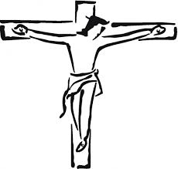
‘Shattered and broken, the survivors of my generation were then returning from the camps and hospitals to the lecture room. A theology which did not speak of God in the sight of the one who was abandoned and crucified would have had nothing to say to us then’.

(Moltmann. J. 1973 The Crucified God Harper Row Pub’ San Francisco P.1)

There is suffering on a genocidal scale within the Christmas Story too, in the slaughter of infant boys aged 2 and under by Herod’s forces. For obvious reasons these events are omitted from the standard re-telling of the nativity story, even the church commemorates this event on the relatively quiet day of December 28th with very few having any form of service to mark that awful occasion.

The events of Holy Week and Easter, whilst ending on a positive note of astonishing proportions, remind us that God intimately understands human suffering and did not shirk it when it came his way. We have a God who in Jesus has suffered, which means that we should have no fear in approaching, maybe even confronting him when suffering comes our way.

The Evolution of Marriage (with reference to same sex marriage)

In the debate leading up to the Marriage (Same Sex Couples) Act 2013, it was suggested that marriage is set in tradition and history and you can’t just change it overnight. If that is true (that marriage is a constant), then we must stand very firm and defend marriage as it has always been understood. But has our understanding of marriage been constant? There is plenty to suggest that there has been significant and continuous development over the years.

Tradition and history take us back to the days of the Old Testament when polygamy was widely accepted. As early as Genesis 4 we read that Lamech had two wives. A little later, Abraham’s grandson, Jacob (an ancestor of Jesus), had two wives – Leah and Rachel. King Solomon (whom God commends for his great wisdom) had 700 wives. By New Testament times, wives in quite that number were less common but polygamy was still in existence. Paul writes to Timothy that a leader in the church should have only one wife. Already, we are seeing a development in the traditional understanding of marriage.

In the marriage service used by the Church of England, we define both the nature and purpose of marriage. From the 1662 Book of Common Prayer (which closely follows the first Prayer Book of 1549), through the 1928 service and now in Common Worship, we see a developing understanding of the purpose of marriage. In all three forms of service, three reasons are given for marriage but with subtle, but important, changes.

In the 1662 and 1928 rites, marriage is given first for having children, second for sex and third for “the mutual society, help and comfort that the one ought to have of the other”. However, the language changes.

Looking at sex (the second reason for marriage), in 1662, we read that “marriage was ordained as a remedy against sin, and to avoid fornication”. It gives the message that sex is a bad thing (unless you are doing it to have children) but, if you must do it, get married and keep it out of sight.

By 1928, the language had changed. Marriage “was ordained in order that the natural instincts and affections, implanted by God, should be hallowed and directed aright.” It’s still talking about sex – but in a more positive light.

By the time Series Three and the Alternative Service Book (1980) came into being, marriage is given that, “with delight and tenderness, they may know each other in love, and, through the joy of their bodily union, may strengthen the union of their hearts and lives.” Today, Common Worship speaks of the couple being brought together “in the delight and tenderness of sexual union”. What was seen as a remedy against sin in 1549 and 1662 becomes, in the 20th and 21st Centuries, a joy and delight, the fulfilment of God’s purposes.

Allied with that, the order of the three reasons for marriage has been reversed. Today, we have as the first reason, “that husband and wife may comfort and help each other, living faithfully together, in need and in plenty, in sorrow and in joy.” Sex is still second and having children comes third. Very few people would suggest that a childless marriage (whether by choice or otherwise) is any less a marriage than one with children. What we are now saying is that the quality of the relationship must come first.

A significant moment in all this was the Lambeth Conference of 1928, when the gathered bishops agreed that the use of contraceptives was consistent with God’s plan for marriage. Immediately sex, in the eyes of the church, was about more than having children. Bodily union was acknowledged to be something which, in itself, would strengthen a relationship, rather than the sin which is implied in The Book of Common Prayer if having sex was not intended for procreation. What we are seeing here is a growing emphasis on the relationship - with children being an important rather than essential part of the marriage. We certainly wouldn’t say in the 21st Century that a couple who are over the age of child-bearing, or who had taken a conscious decision not to have children, could not marry.

Changes in our understanding of marriage have also evolved with our developing view of the role and place of women, both in marriage and in wider society. It is in relatively recent times that women have a legal status in their own right; a woman was effectively owned by her husband until the Married Women’s Property Acts of the nineteenth century. This is reflected in the words of the marriage service. In the 1662 Book of Common Prayer, the priest pronounces that they be “man and wife together”. Today the priest proclaims that they are “husband and wife together”. It’s a subtle but important change. In the first instance he is described as a man, a description of who he is, regardless of anyone else. She, however, is called a wife; in other words, she is described only by her relationship to the man. To call them Husband and Wife describes them both by their relationship to each other. We have moved from ownership to partnership – partnership between two equals. This partnership of equals is also symbolised by the removal of the requirement for wives to promise to obey their husbands.

Notwithstanding Canon B30.2 which says that the teaching of our Lord affirmed by the Church of England is expressed and maintained in the Form of Solemnization of Matrimony contained in The Book of Common Prayer, what this glimpse into history reveals is anything but an institution which is fixed in tradition and history. We now have an understanding of marriage as an unconditional commitment between two equal people who, in love, share everything together, including their bodies. It’s a commitment which usually leads to children, but which often doesn’t. If we accept, therefore, that our understanding of marriage has developed as our understanding of what it means to be human has developed, then the question we have to answer is: “Have we reached the perfect description of marriage? Or will our present definition of marriage be further developed, perhaps even to include the possibility of a marriage partnership between two people of the same gender?”

Turning to the Bible, it is clear that there are people on both sides of this debate who take scripture seriously. Dismissing those who disagree with us as people who don’t place sufficient emphasis on the Bible as the Word of God, simply ignores reality. However, this is not the place for an in-depth analysis of the Biblical material other than to remember that, when analysing Biblical texts, it is important to look at the context. In the 1st Century there was no understanding that someone could be a homosexual; in those days, there were only heterosexuals who sometimes engaged in homosexual behaviour which, according to Chapter 1 of Romans, was against their nature. It was not until the 19th Century that we began to realise than people could be homosexual by orientation; that it is part of their nature to form a sexual relationship with someone of the same gender, rather than such behaviour being unnatural or a lifestyle choice. Not until the second half of the 20th Century, did we put that into practice in the UK by de-criminalising homosexual behaviour. The context of the New Testament is that Paul is writing from a belief that you couldn’t BE homosexual. He wasn’t condemning homosexuals because, in his view, there was no such person as a homosexual – only heterosexuals who engaged in homosexual acts.

The challenge for us is to interpret, not just the passages which are about sexual behaviour, but all of the Biblical teaching about faithfulness in relationships from a modern understanding that some people are homosexual. They didn’t choose it, any more than people chose to be male or female and the church has already gone some way in recognising this by accepting the validity of Civil Partnerships.

The Marriage (Same Sex Couples) Act 2013 permits two people of the same gender to marry, but it is illegal for that marriage to be solemnised in the Church of England. Despite reference in the 2013 Act to the Submission of the Clergy Act 1533 which states that there can be no Canons of the Church of England which are contrary to the customs, laws or statutes of this realm, the Church and the Law of the land have different understandings of marriage.

And yet, the development of the Church of England’s understanding of marriage has very firmly emphasised the quality of the relationship between the couple, recognising committed love as the most important ingredient. There are many in the Church of England who believe that the development of marriage has further to go, so that faithful, permanent, enriching relationships – something we hope for in all marriages – can and should be extended to include those of the same gender.

John Ashe Archdeacon of Lynn

Prayer Corner

“Courage does not always roar.
Sometimes courage is the quiet voice
At the end of the day saying,
I will try again tomorrow”

Mary Anne Radmacher

Thorpe Gardening Club
Our February meeting was a picture show by Brian Hedge, of five gardens he would recommend for a visit, when you are in need of a break from your own plot. Brian, a keen history man, being involved with North Walsham Archives, is a collector of old photos and makes them into presentations which he shows at various locations, subjects cover all areas of life in old time Norfolk, but his wife is a keen flower arranger and so the odd garden and flower related presentation has been added to his talks list over the years.
His favorite garden is the Beth Chatto garden in Suffolk which was one of the featured gardens, along with Hidcote Manor in the Cotswolds, Compton Acres in Dorset, Abbotsbury sub tropical gardens near Weymouth and Bodnant gardens in Wales.
After the February weather this year that had many of us frustrated at not being to get on with jobs in the garden, it was nice to see lots of flowers in the sunshine, making us look forward to the coming months with renewed enthusiasm.

Our forthcoming meetings are, on April 25th Robin McDonald talking about Orchids, followed on May 30th by Bob Coutts talking about Herbaceous Borders. Meetings start at 7.30pm, St Francis Church Hall, Rider Haggard Rd, Heartsease, NR7 9UQ. Also we are holding our Annual Plant Sales at 37 Eastern Ave, Thorpe St Andrew, NR7 0UQ on May 13th 10am till 3pm and May 14th from 10am till 2pm. Then on May 20th from 10am till 4pm and May 21st from 10am till 2pm at 2 Linacre Avenue, Sprowston, NR7 8PE.
Further details from Maureen Street on 01603 438370 or email maureen.street@ntlworld.com.
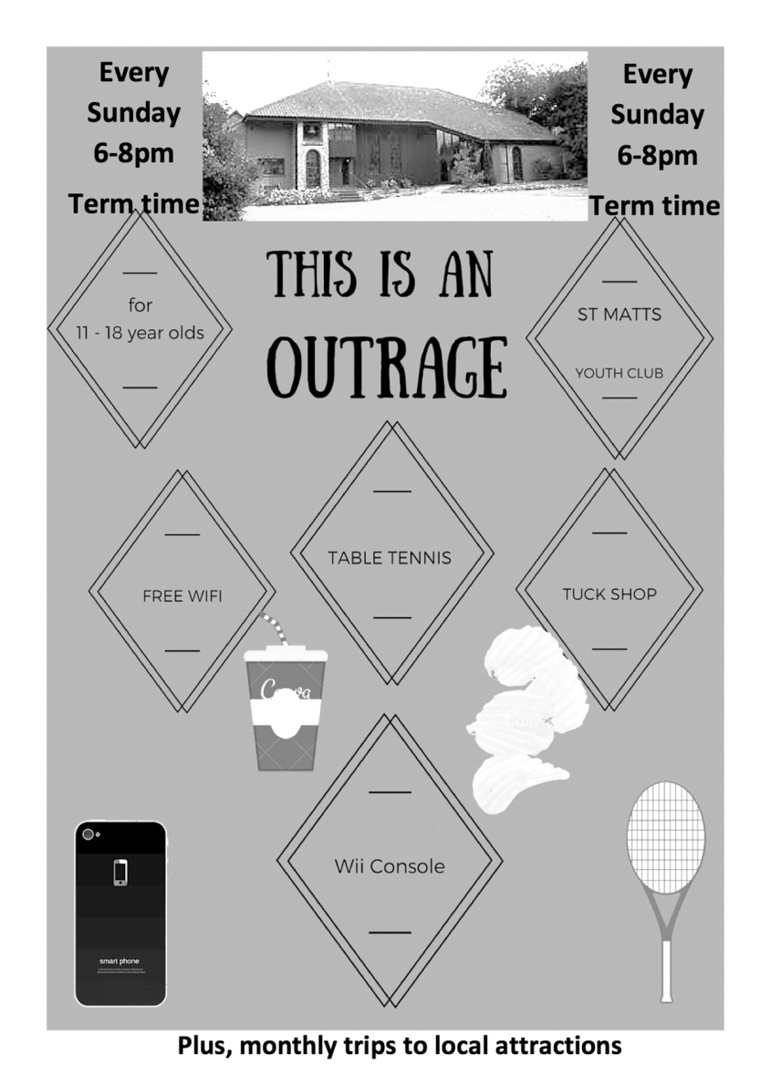

Cipolline in agrodolce (sweet and sour pickled onions )
I have to admit this isn't a recipe solely from Parma, but I had such fun making it and it was just so easy, I had to include it. Unlike our pickled onions, they don't have a long shelf life, but in jars will last for a week in the fridge. You can eat them hot as a side dish with virtually any grilled meat or fish or even cold with cheese.
For every 300 grams of pickling onions, or shallots you need
80 grams honey (the original recipe called for chestnut honey )
50 grams balsamic vinegar
(I added a splash of distilled malt vinegar or red or white wine vinegar just to cut through the sweetness).
I only put a large pinch of salt but depending on your taste you can add more.
Start by melting the honey on a med heat in large pan, let it bubble a little then add onions letting them caramelise, it will take about 5 minutes, stirring continuously with a wooden spoon. Then add salt and vinegars. Let it cook on a low heat until liquid has reduced to a thick sauce, it may take about 10 to 12 minutes or until onions have softened. If you want the onions softer then carry on cooking for further 5 to 10 mins, taking care not to let it burn.
Buon appetito

.On the Rota
By Victoria Hook
Lisa looked in dismay at the large, black splodge on the wall. She took her duster and dabbed nervously at the mark.
‘Don’t panic,’ Lisa told herself as she trotted over to the kitchen area to get a damp cloth. Her instructions however had been clear. Pat, the chief of the brass cleaning rota had been quite specific.
‘Whatever you do, don’t get any brass cleaner on the wall,’ Pat had warned, adding, ‘If necessary, don’t even worry about cleaning right up to the edge of the wall plaques.’
‘Well, I’ve done better than that, I haven’t cleaned the plaques at all,’ Lisa thought to herself. ‘All I’ve managed to do is to spill half a pot of Brasso down the wall.’
Lisa hurried back across the church and drew the cloth across the offending black stain and watched in horror as it spread, greyish tendrils snaking gracefully across the whitewashed wall. As she contemplated the ramifications of this latest disaster, Lisa heard the sound of a car pulling up on the gravel outside the church. She just managed to untie her apron and hang it jauntily over the brass plaque, cunningly covering the stain and then race back to the kitchen area to rinse the tell-tale cloth before the Church door opened.

‘Oh, hello, Lisa,’ exclaimed Christine as she spotted Lisa scrubbing the kitchen surfaces purposefully. ‘That’s kind of you. I’m having an awful morning. I’d completely forgotten that I’m down to do teas for the toddler group and I’m meant to be picking Lucy up from nursery at 12 and I’ve tried ringing round and no one else can do the teas and…’ Christine paused momentarily, looking forlornly at Lisa.
‘Look, it’s OK, Christine, I’ll stay and do the teas,’ Lisa said before she could stop herself.
‘Oh no, I couldn’t … well if you’re absolutely sure … ah thanks, Lisa that’s brilliant,’ Christine gabbled, and with that, she was gone.
‘Brilliant,’ thought Lisa miserably.
When the toddler group had finally dispersed and Lisa had washed up the last of the mugs, she walked home.
‘What I’ll do,’ she told herself, ‘is get that white paint out of the shed, paint over the Brasso mark and nobody’ll be any the wiser.’ The pot of paint was a lot larger than Lisa had remembered so she decanted a blob into a jam jar and set off back to the Church. Relieved to find the Church deserted, she set about painting over the stain. The results were pleasing. The bluey black bruise of the stain was no longer visible. Admittedly the fresh white paint was a slightly different shade from the wall, but Lisa felt confident that it would dry to the same colour. Just as she was about to pack her brush and jar into her bag Lisa heard a
‘Yoohoo.’ Startled, she turned to see Diana standing just metres away. ‘Don’t mind me,’ Diana said, ‘I’ve just been dropping off some buckets of greenery in the vestry.’
‘Oh,’ Lisa started, trying desperately to think what she could say she’d been doing, whilst manoeuvring herself to shield the wall painting from Diana. ‘I’ve been painting,’ she stumbled, totally unable to bring herself to lie.
‘Oh, how lovely Lisa. I didn’t know you were an artist,’ Diana said. ‘Why haven’t you told me that before? We need all the creative sorts we can get for the flower rota. Ooh, thinking about it, why don’t you do a little arrangement for Harvest on Sunday? Now, I know how modest you are, but I won’t take no for an answer.’ Diana folded her arms as if to settle the matter.
‘I’d love to,’ Lisa winced as she heard herself say it.
‘Excellent, we’ll all be here at 10 on Saturday, but you can do your display anytime that suits you,’ Diana announced, as she turned to leave.
‘Excellent,’ thought Lisa despairingly.
When Lisa arrived home from the Church for the second time that day, she filled the kettle and sat down to wait for it to boil. It wasn’t true to say that she was not artistic, but she had never arranged flowers formally in her life. She had certainly not tried to arrange flowers in front of an audience, especially when that audience consisted of group of ladies who were frighteningly talented.
‘I’ll just have to do my arrangement tomorrow, before the others get there on Saturday,’ she reasoned with herself.
The next day, Lisa set off for the Church armed with greenery from her garden and cellophane-wrapped flowers. She supposed that one probably needed other things like oasis and wire and secateurs to look the part, but undeterred, she opened the Church door. She stopped in her tracks as she looked over to the Brasso fiasco area. The white of her fresh paintwork was startling.
‘Oh heavens,’ Lisa gasped. Short of repainting the whole Church, she could think of nothing she could do to cover up her latest debacle. ‘Aha,’ her little brain was whirring. ‘I shall just have to do a huge flower arrangement in front of it,’ she announced to herself, pleased with her solution. Once she got going, Lisa found she was rather enjoying herself. The great fronds of greenery cast a forgiving shadow over the naked white wall and very soon Lisa was lost in her own little world and began to sing quietly to herself. She would have been quite happily engaged in her new found art form had it not been for the sudden boom of the organ. Lisa, who had been sitting on her haunches fiddling with a traily bit of asparagus fern, tipped backwards in her surprise and in doing so let out a small yelp.
‘Golly, are you OK,? David called across from the organ. ‘Sorry, I did call out when I came in but perhaps you didn’t hear me.’ David climbed down from the organ stool and came over to help Lisa up. ‘I was rather enjoying your singing too,’ David said, and Lisa felt herself blush. ‘I don’t suppose you fancy joining the choir do you?’ he asked, almost apologetically. Lisa was so taken aback she had agreed to sing for the next evensong, before she had time to think. ‘That’s fantastic, we rehearse tonight at six,’ stated David.
‘Fantastic,’ Lisa echoed faintly.
It was with some trepidation that Lisa filed down the aisle in a borrowed cassock and surplice on the Sunday evening, but as soon as Evensong began the familiarity of the words calmed her.
‘Spare thou them, O God, which confess their faults,’ she recited and felt herself redden slightly at the thought of the Brasso business.
‘The first lesson is taken from Proverbs Chapter 28 starting at verse 13,’ the vicar announced. ‘People who conceal their sins will not prosper, but if they confess and turn from them, they will receive mercy,’ he began.
Lisa didn’t really hear any more of the reading. In fact, it would be true to say that her concentration during the singing was pretty poor too, but by the end of the service she felt decidedly light-headed. She barely waited until her robes were back on the hanger before spilling out the details of her week to anyone prepared to listen.

Groups Clubs and special events.
Information and contact details are given below for the activities that happen at St Matthews.

Day | Time | Group | Cost | Contact
Monday | 10- 11am  1830-2000 | Extend exercise class for seniors  Jing Tsun | £3 | Church office  tel 763695  Brett Porter
Tuesday | 1230 1400 | Lunch club | £4.50 | Church Office
Wednesday | 1000-1200 | Table Tennis Club | £1.50 | Mary 660132
Thursday | 900-1100 | Play Café (toddler group | £2 per family | Rev Patrick Jordan  494015
Friday | 0900-1400  1400-1600 | International Friendship group  Social Club | Free  £2.00 | Bridgid621020  Church office

APRIL SERVICES
2 Passion Sunday Holy Communion 8.00am
Holy Communion 10.30am
5 Wednesday Holy Communion 9.30am
9 Palm Sunday Holy Communion 8.00am
Holy Communion 10.30am
10 Monday Stations Meditations 1 7.00pm
11 Tuesday Stations Meditations 2 7.00pm
12 Wednesday Holy Communion 9.30am
Stations Meditations 3 7.00pm
13 Thursday Foot washing Communion 7.00pm
14th Friday Good Friday workshop 10.00 - 12.00am
Hour at the Cross 2.00 - 3.00pm
15 Saturday Easter Vigil and Confirmations -
Cathedral 8.00pm
16 EASTER DAY Holy Communion 8.00am
Holy Communion 10.30am
19 Wednesday Holy Communion 9.30am
20 Thursday Community Communion 3.30pm
23 Easter 2 Holy Communion 8.00am
Holy Communion 10.30am
26 Wednesday Holy Communion 9.30am
30 Easter 3 Holy Communion 8.00am
Holy Communion 10.30am
MAY SERVICES
3 Wednesday Holy Communion 9.30am
7 Easter 4 Holy Communion 8.00am
Holy Communion 10.30am
10 Wednesday Holy Communion 9.30am
14 Easter 5 Holy Communion 8.00am
Holy Communion 10.30am
17 Wednesday Holy Communion 9.30am
18 Thursday Community Communion 3.30pm
21 Easter 6 Holy Communion 8.00am
Holy Communion 10.30am
24 Wednesday Holy Communion 9.30am
28 Easter 7 Holy Communion 8.00am
Holy Communion 10.30am
31 Wednesday Holy Communion 9.30am

St Matthews Roof Appeal
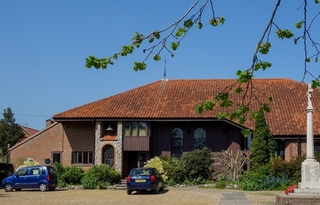
An appeal to repair the roof at St Matthews Church was launched to the congregation at the end of January. The roof leaks and an investigation by our architect reveals that the whole thing is in a bad way. It has been patched over the last few years, but the time has now come for a complete repair. So, with the cry of 'Let's fix the roof "we started, and the good news is that we have already reached the first target of £10,000 by Easter. The congregation has risen to the challenge magnificently . Donations large and small have helped to keep the total moving upwards, and the fundraising events at St Matthews have been very well supported and proved most profitable, so onwards and upwards, there is a long, long way to go .
Forthcoming Events At St Matthews

FISH Lunch April 13th 12.30pm
APCm 23rd April after the 10.30am Service
Afternoon Tea Saturday 13th May 3-5pm
Flower Festival June 10th 11th
Fete and BBQ (Coinciding with Gas Hill gasp)
July 7th 6pm

At Norwich Cathedral

Hearing Voices
Listening to those living with Mental Health issues Wednesday 5th July

lettings & property management
For local independent advice with exceptional
customer service and competitive rates call today!!

Visit us at our office at - 203a Wroxham Road, Sprowston
Or call us on: 01603 487070

Contacts at St Matthews
Vicar: Revd Patrick Jordan
Vicarage 01603 494015
revpatrickjordan@gmail.com

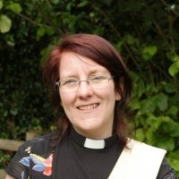
Curate: Revd Helen Rengert
Office: 01603 494015
revdhelen@yahoo.co.uk

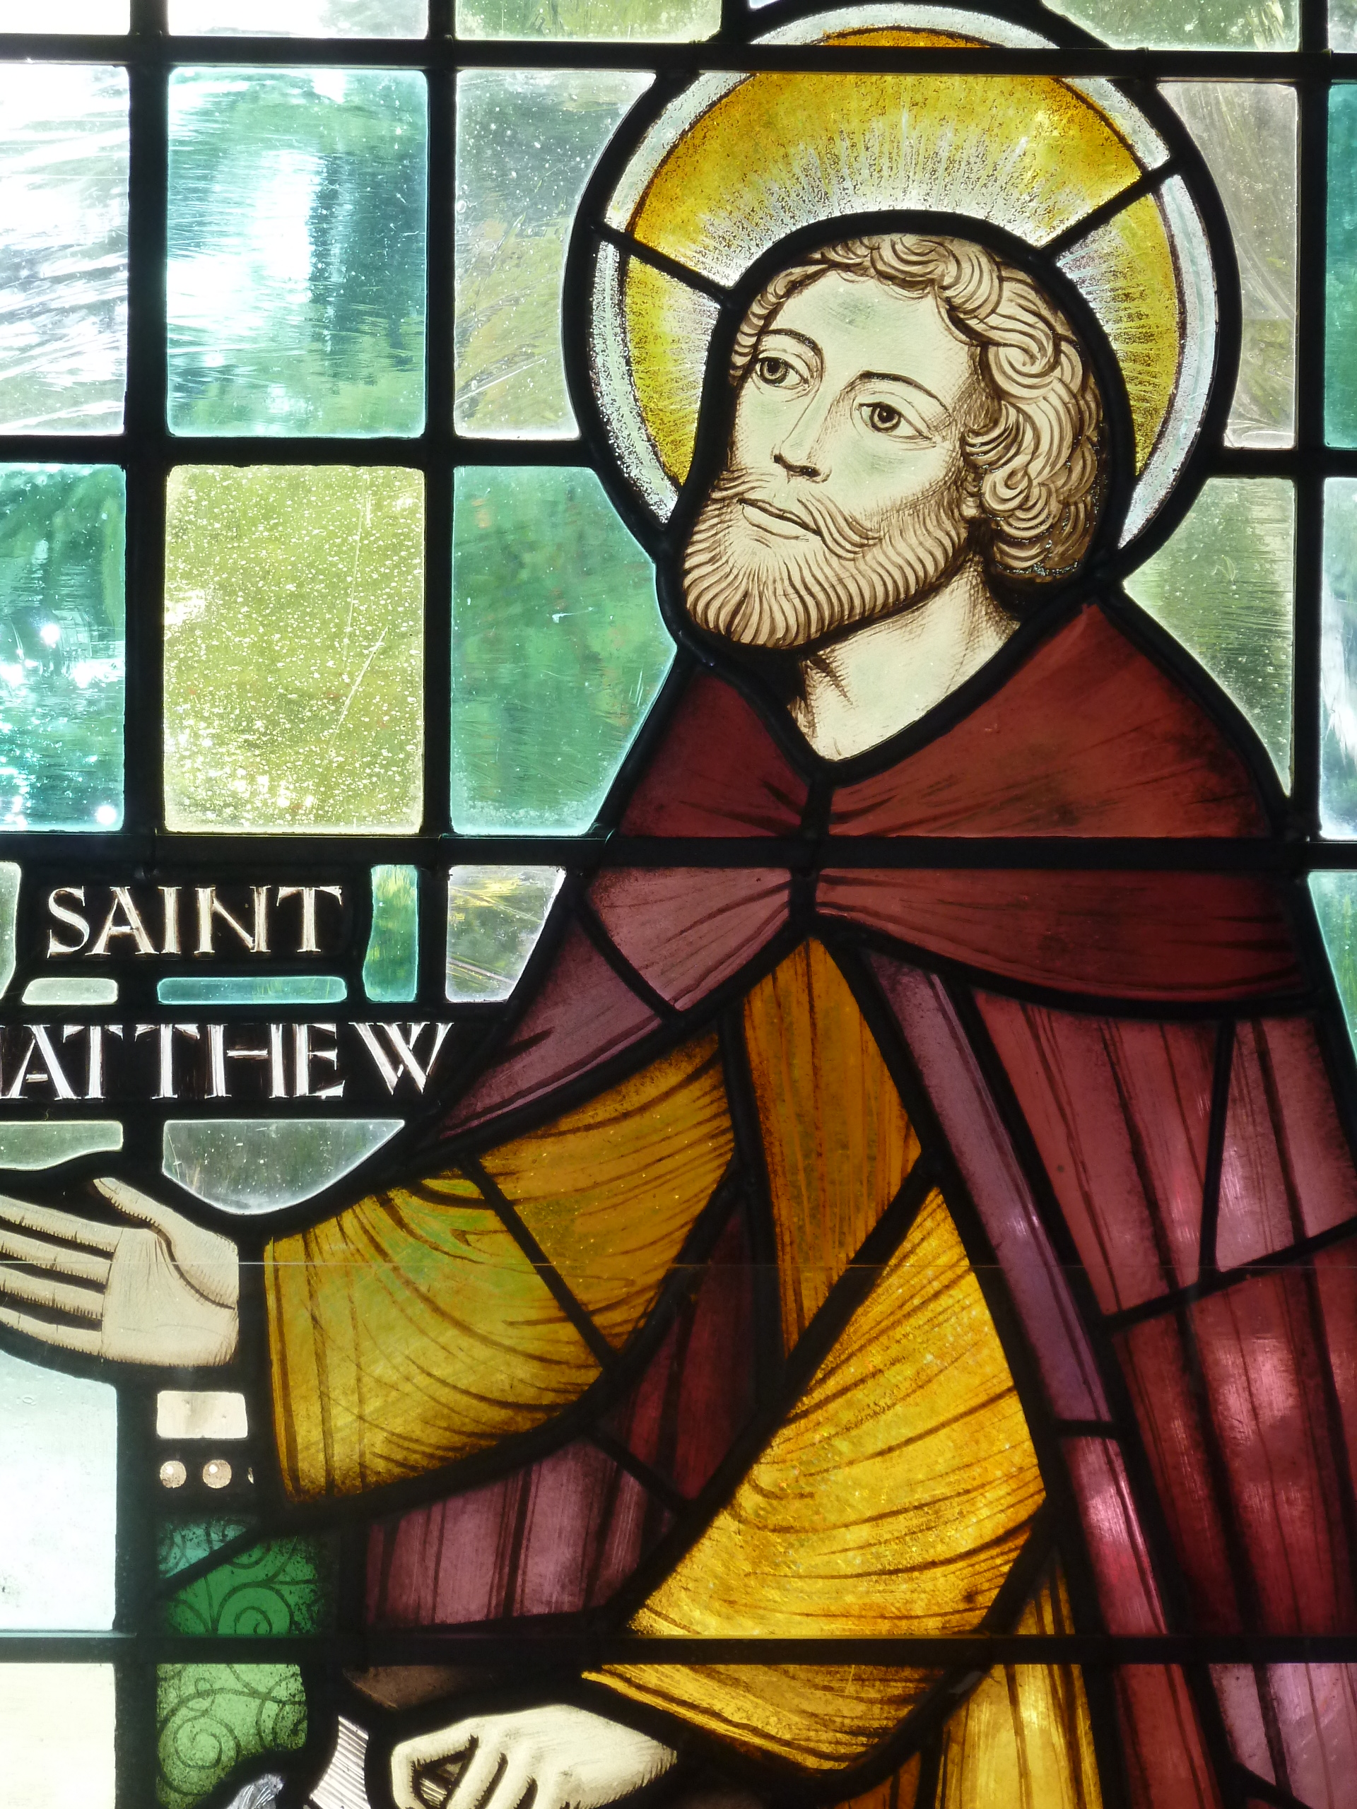
Saint Matthew”s Church
Telegraph Lane West
Thorpe Hamlet
Norwich NR1 4JA

Room Hire
Mrs Bridget Everett
01603 763 695

Magazine Editors stmattsmag@gmail.com

Magazine Adverts
Mark Chapman
462873
mattchapman@ntlworld.com

For other contacts please visit our website at www.stmatthewschurch.org.uk

